**Solutions**

**Data structures and algorithm**

**Q1.InventoryManagementSystem**

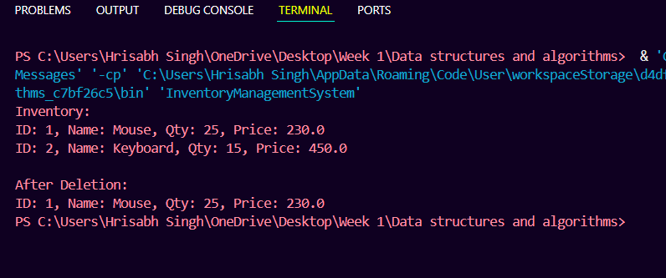

**Q2.ECommerceSearch**

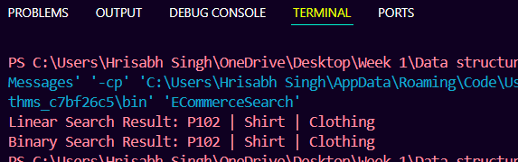

**Q3.OrderSorting**

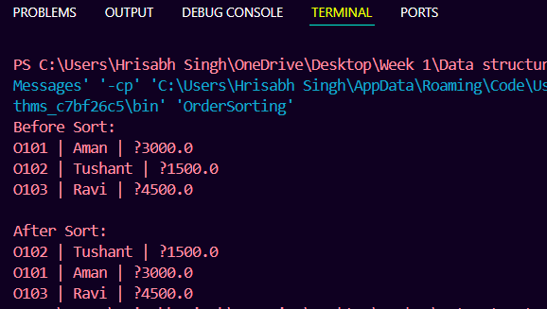

**Q4.EmployeeManagement**

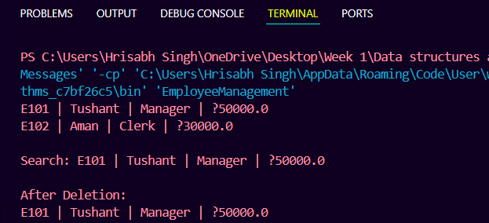

**Q5.TaskManager**

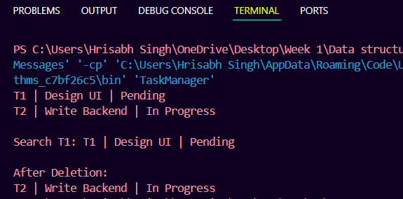

**Q6.LibrarySystem**

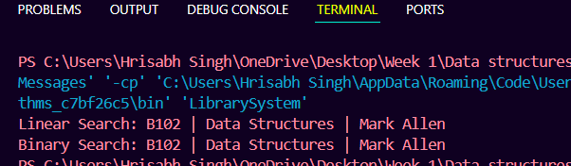

**Q7.FinancialForcasting**

